Functional Specification

Year: 2018 Semester: Fall Team: 7

Project: Handi_glove

Creation Date: 8-29-2018 Last Modified: 9-5-2018

**Member 1:** Yaodong Shen **Email:** shen234@purdue.edu

**Member 2:** Jia En Chua **Email:** chuaj@purdue.edu

**Member 3:** Yao Chen **Email:** chen1748@purdue.edu

**Member 4:** Carol Lo  **Email:** lo40@purdue.edu

Assignment Evaluation:

|  |  |  |  |  |
| --- | --- | --- | --- | --- |
| **Item** | **Score (0-5)** | **Weight** | **Points** | **Notes** |
| **Assignment-Specific Items** | | | | |
| **Functional Description** | 5 | x3 | 15 |  |
| **Theory of Operation** | 5 | x3 | 15 |  |
| **Expected Usage Case** | 5 | x3 | 15 |  |
| **Design Constraints** | 4 | x3 | 12 |  |
| **Writing-Specific Items** | | | | |
| **Spelling and Grammar** | 3 | x2 | 6 |  |
| **Formatting and Citations** | 5 | x1 | 5 |  |
| **Figures and Graphs** | 5 | x2 | 10 |  |
| **Technical Writing Style** | 4 | x3 | 12 |  |
| **Total Score** | 90 | | |  |

5: Excellent 4: Good 3: Acceptable 2: Poor 1: Very Poor 0: Not attempted

General Comments:

*The electronics constraints part seems complicated. You are considering too many sensors. Design something simpler first. You can always add more functionalities later.*

1.0 Functional Description

The device, Handi_glove, will serve as a quasi-telemanipulation device with various physical feedbacks. Specifically, the user will wear a glove that is equipped with Motion restraint system, touch sensors, and temperature detection devices that communicates with a robotic hand. The goal is to allow the user to physically “feel” the properties that the robotic hand detects. The robotic hand motions are directly controlled through the glove movement, mimicking its actions. Consequently, when the robotic hand encounters any obstacles or comes into contact with any external objects, the user would be able to receive the movement restraint, touch, and temperature feedback from the object in question.

In the event of picking up a hot/cold object, the user would be able to feel the actual temperature of the object. In addition, should the user attempt to exert force onto the metal block, they would receive movement restraint and touch feedback from the glove’s mechanical components, as if they were physically holding the block.

The goal of the creation of this device is to maintain and improve safety protocols within research environments while helping researchers conduct experiments in a more efficient and effective manner. In order to comply with the intention of the project, safety thresholds are placed on the device. The device worn by the user will not exert a force or emit a temperature that is harmful to human skin, instead, hazardous warnings will be issued in the case where the physical conditions in question can no longer be safely imitated and communicated.

2.0 Theory of Operation

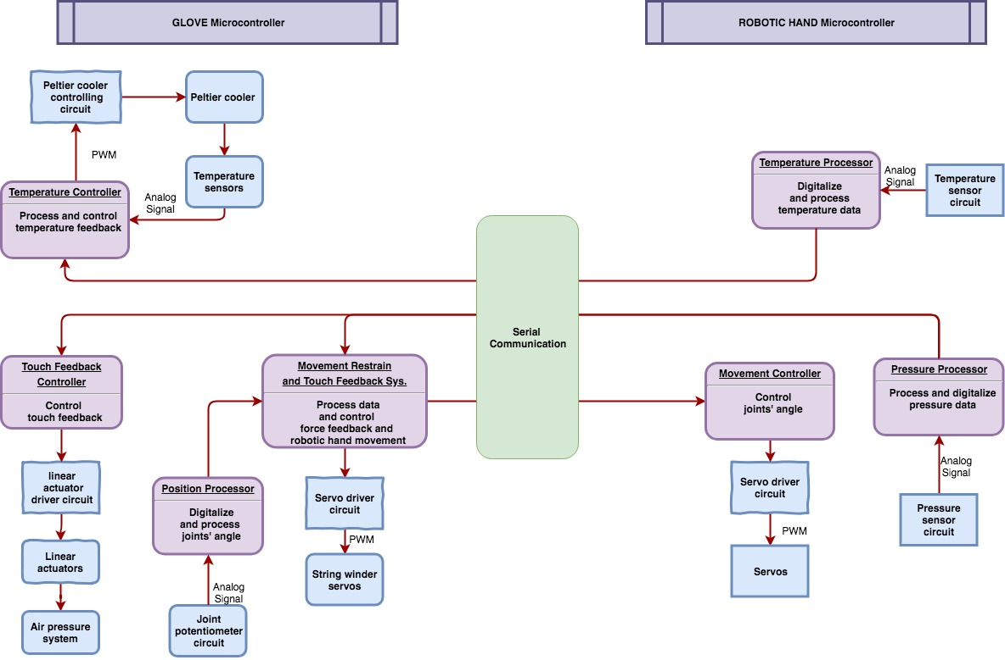

Our project is a glove-robohand system consisting of two parts: a robotic hand and a user-controlled glove.

In order to perform the movement of robotic hand, potentiometers placed on the glove exoskeleton joints are used to monitor the joint angles. A servo controlling algorithm will be developed to emulate finger movement.

In order to provide temperature feedback, temperature sensors will be placed on the tip of the robotic fingers and Peltier modules on the glove will be used to realize the cooling and heating effect. A Peltier module is a solid-state device often used for heat transfer. The cooling effect can be perceived by user’s finger in 1 seconds and heating in approximately 2 seconds. An optional thermal silica layer can serve as a protective layer between user skin and the Peltier module. Optional temperature sensors can be placed between user skin and Peltier module to construct closed loop system to stabilize temperature response.

In order to provide the touch feedback, pressure sensors placed on the tip of the robotic fingers will be used to collect touch force data and linear actuators and air pressure system are employed to produce the sense of touch. Specifically, small airbags placed under the fingers in the glove will inflate or deflate depending on the situation in order to mimic the sense of touch.

In order to simulate the physical restraint, the glove exoskeleton will apply resistive force on each finger. When pressure sensors on robotic hand detect touch, an algorithm will control servos to pull tension cables on the glove to restrict the finger movement.

Finally, the robotic hand will be initialized to a pre-specified standby position, every time the system is initialized / unexpectedly loses power. Additionally, the robotic hand will be restored to the standby position, when the user takes off the glove.

3.0 Expected Usage Case

Handi_glove is designed to provide a safe means of operating under potentially hazardous conditions semi-remotely. The device is expected to be used in industrial and research environments, particularly environments where human direct contact with certain objects are considered potentially hazardous.

This project is intended to be used in a stationary setting because our main target user is lab researcher and industrial worker. Their work is usually done under a stationary environment such as laboratory and factory. Therefore, we can consume power source from socket by the wall instead of battery. Also, we do not need to implant servo on the glove to provide force feedback. Instead we could create a packaging box to install all the servos and thus reduce the weight of glove.

The demographic of the expected users lies within industrial workers as well as researchers. They will most likely be adults conditioned in the workforce who have had some experience in operating under physically hazardous conditions and are well trained in safety protocols due to the nature of their industry. The level of technical literacy may not necessarily be high, but to a level that allows them to safely operate most conventional machines used in industry. They will most likely be required to have physical abilities that will allow them to regularly use a glove to perform various movements.

4.0 Design Constraints

4.1 Computational Constraints

The program should take linear time to operate because essentially, we are running sequential, straight-forward logic to control servo to pull or push cable to mimic fingers’ movement. We also need to generate heating/cooling effect according to temperature sensor’s reading and this can be done in linear time complexity because essentially the microcontroller just receive value, do some basic mathematical calculation and send value out. To be more specific, ADC will be used to convert analog signal from potentiometer and sensors to digital signal. We then use PWM to control the angle of servos and then push or pull tension cable.

In terms of memory constraint, we only need to record the initial fingers’ position (which could be just a few constant integers) to fulfill one of the PSSC which is to reset the robotic hand back to original state. Thus, we don’t require a large memory to store any data or to make use of any complex algorithm.

4.2 Electronics Constraints

The major components in our project are mentioned as follows:

* Two microcontrollers will be used in this project, one for the glove and another for the robotic hand and serial communication will be used to exchange data between the microcontrollers.
* Approximately 7 temperature sensors, 7 pressure sensors and 14 joint potentiometers will be used on the glove part; 7 temperature sensors, 7 pressure sensors will be used on the robotic hand part. With those sensors, 28 ADC ports will be used in a single microcontroller.
* A cooler driver circuit to support stable and quick temperature feedback, 7 output ports will be used on the glove microcontroller to control coolers.
* A servo driver circuit will use 14 output ports on the robotic hand microcontroller and 5 output ports on the glove part.
* A linear actuator driver will use 7 output ports on the glove microcontroller.

In total the glove microcontroller will use 47 ports and 28 of them are ADC ports; the robotic hand microcontroller will use 28 ports and 14 of them are ADC ports;

External ADC might be needed in our project.

Fewer number of I/O’s and sensors may be used in the actual project.

4.3 Thermal/Power Constraints

According to STM32F427xx datasheet [5], the estimated power consumption will be around 120mA with a voltage of 4V and the estimated operating temperature range falls between -40 to 105 degree Celsius. Although our project is temperature-sensitive, the microcontroller resides in a packaging box which is away from the glove. Therefore, the heat dissipation from microcontroller will not affect the temperature feedback. This project is designed to be utilized under stationary environment and thus we do not need battery and hence there is no charging issue to deal with.

4.4 Mechanical Constraints

One of the biggest mechanical constraints of this project is reducing the handi_glove’s weight. Although the project requires a lightweight material to be used in building the user’s control glove, a lot of different mechanical components cannot achieve the desired effect in delivering different feedbacks. Another mechanical constraint of this project is the force limit of robotic hand actions. Due to the nature of the project, the glove should not be able to move any further than the robotic hand’s movement. Human hands, however, are capable of exerting forces that may damage the glove’s exoskeleton. We resort to adding a machine force threshold escape mechanism. In an event where the force from the user’s hand exceeds our threshold, the glove’s exoskeleton will succumb to the force in order to avoid breakage. It is difficult to achieve this goal, however, because the force from the user’s hand is hard to measure and predict.

Linear actuators will be separately packed in a box. Air tubes will be used to connect the box to the glove.

4.5 Economic Constraints

The use of linear actuators greatly increased the price of the project. Although a typical linear actuator similar to the ones utilized in this project costs around $50 [3] each, we were able to purchase them at a rate of 200 Yuan (approximately $30) per piece. In addition to the main expense on the linear actuators, we aim to limit our cost to around $500 overall with other equipment. In order to get closer to this target, we could look into potential alternative materials. On the market, there exists similar technology that sell the glove for $250 [2] and the robotic arm for $2000 [4].

4.6 Other Constraints

There are no other constraints.

5.0 Sources Cited:

[1] A. Banerji, A. Jaju and P. K. Pal, "Experiments on telemanipulation with ‘delayed live’ video," *2013 International Conference on Control, Automation, Robotics and Embedded Systems (CARE)*, Jabalpur, 2013, pp. 1-6.

[2] Plexus Immersive Corp, “Plexus / High-performance VR/AR Gloves,” *Plexus / High-performance VR/AR Gloves*. [Online]. Available: http://plexus.im/. [Accessed: 30-Aug-2018].

[3] “Your Supermart Multi-function Electric Linear Actuator Motor Heavy Duty DC 12V 4inch -,” *Amazon*. [Online]. Available: https://www.amazon.com/Your-Supermart-Multi-function-Electric-Actuator/dp/B01K6J55C2/ref=asc_df_B01K6J55C2/?tag=hyprod-20&linkCode=df0&hvadid=226601492573&hvpos=1o2&hvnetw=g&hvrand=15629559443012772952&hvpone=&hvptwo=&hvqmt=&hvdev=c&hvdvcmdl=&hvlocint=&hvlocphy=9016722&hvtargid=pla-393435321578&psc=1. [Accessed: 30-Aug-2018].

[4] “Youbionic Robot Left Hand v2,” *RobotShop*. [Online]. Available: https://www.robotshop.com/en/youbionic-robot-left-hand-v2.html.

[5] STMicroelectronics, “STM32F427xx STM32F429xx” datasheet [Revised Jan. 2018] Available: https://www.st.com/content/ccc/resource/technical/document/datasheet/03/b4/b2/36/4c/72/49/29/DM00071990.pdf/files/DM00071990.pdf/jcr:content/translations/en.DM00071990.pdf